Module Name: Login Page - Functional & UI Test Cases
Test Case ID: st_01
Webpage URL:https://www.automationexercise.com/
- Scenario ID : TC01
Scenario : verify login page is accessible .
Test steps :
- Open the browser
- Navigate to the website Locate the Login section/link
- Click on the Login link/button
- Verify the Login page loads with username and password fields visible.
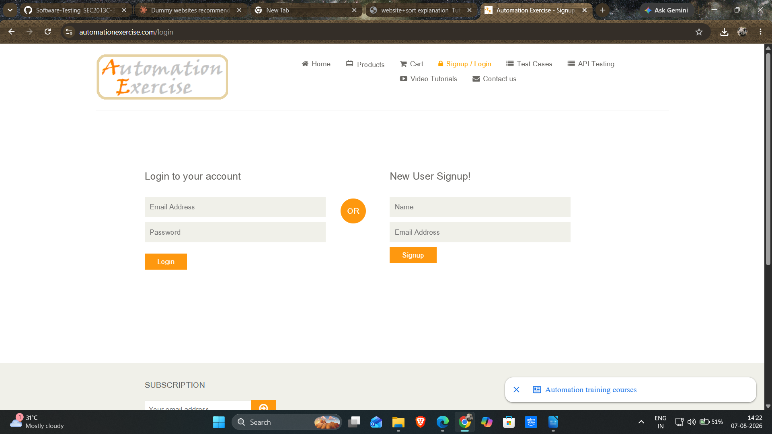

- Scenario ID : TC02
Scenario : verify signup page is accessible . .
Steps:
1. Open browser
2. Open automationexercise.com
3. Click on 'Signup / Login' link
4. Observe the 'New User Signup!' section
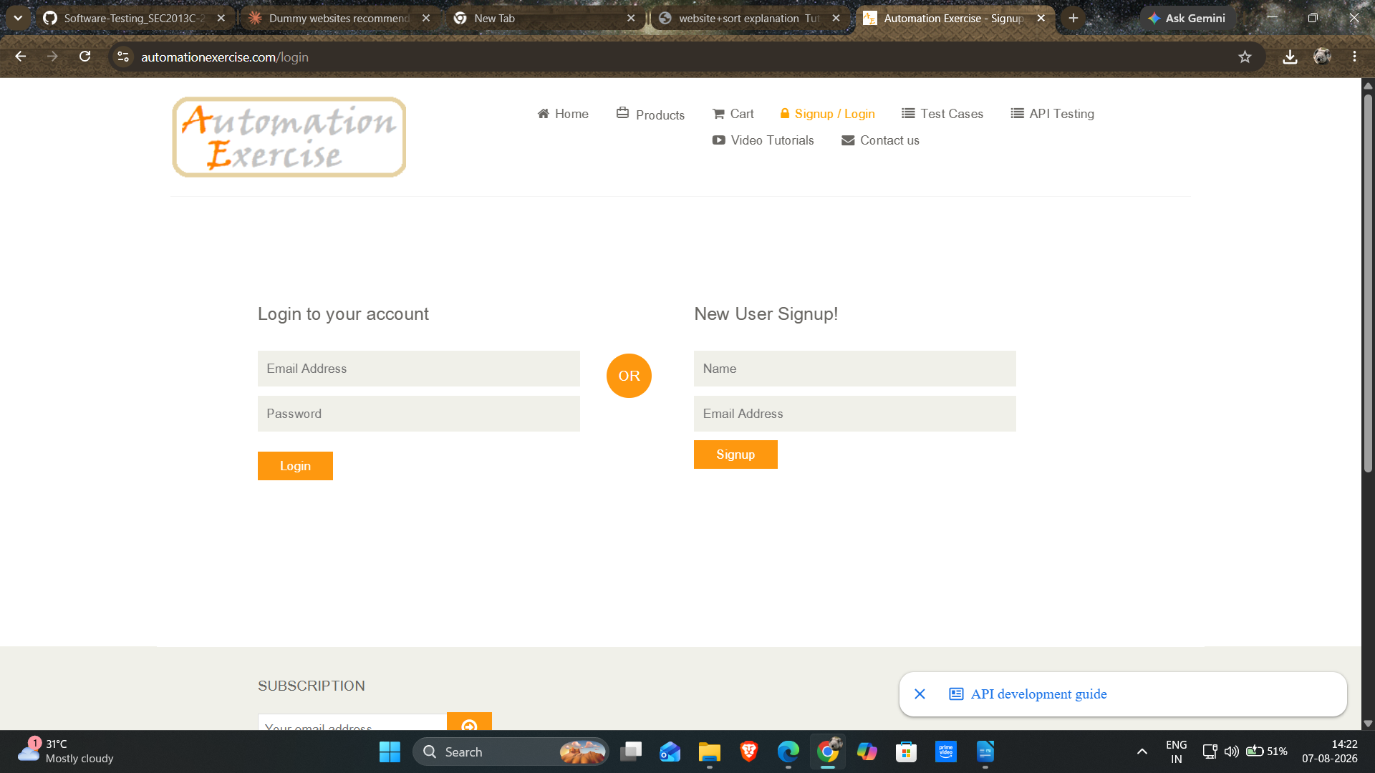
- Scenario ID : TC03
Scenario : verify email field is available on website .
Steps:
1. Navigate to Login page
2. Locate the 'Login' section
3. Check for the email input field 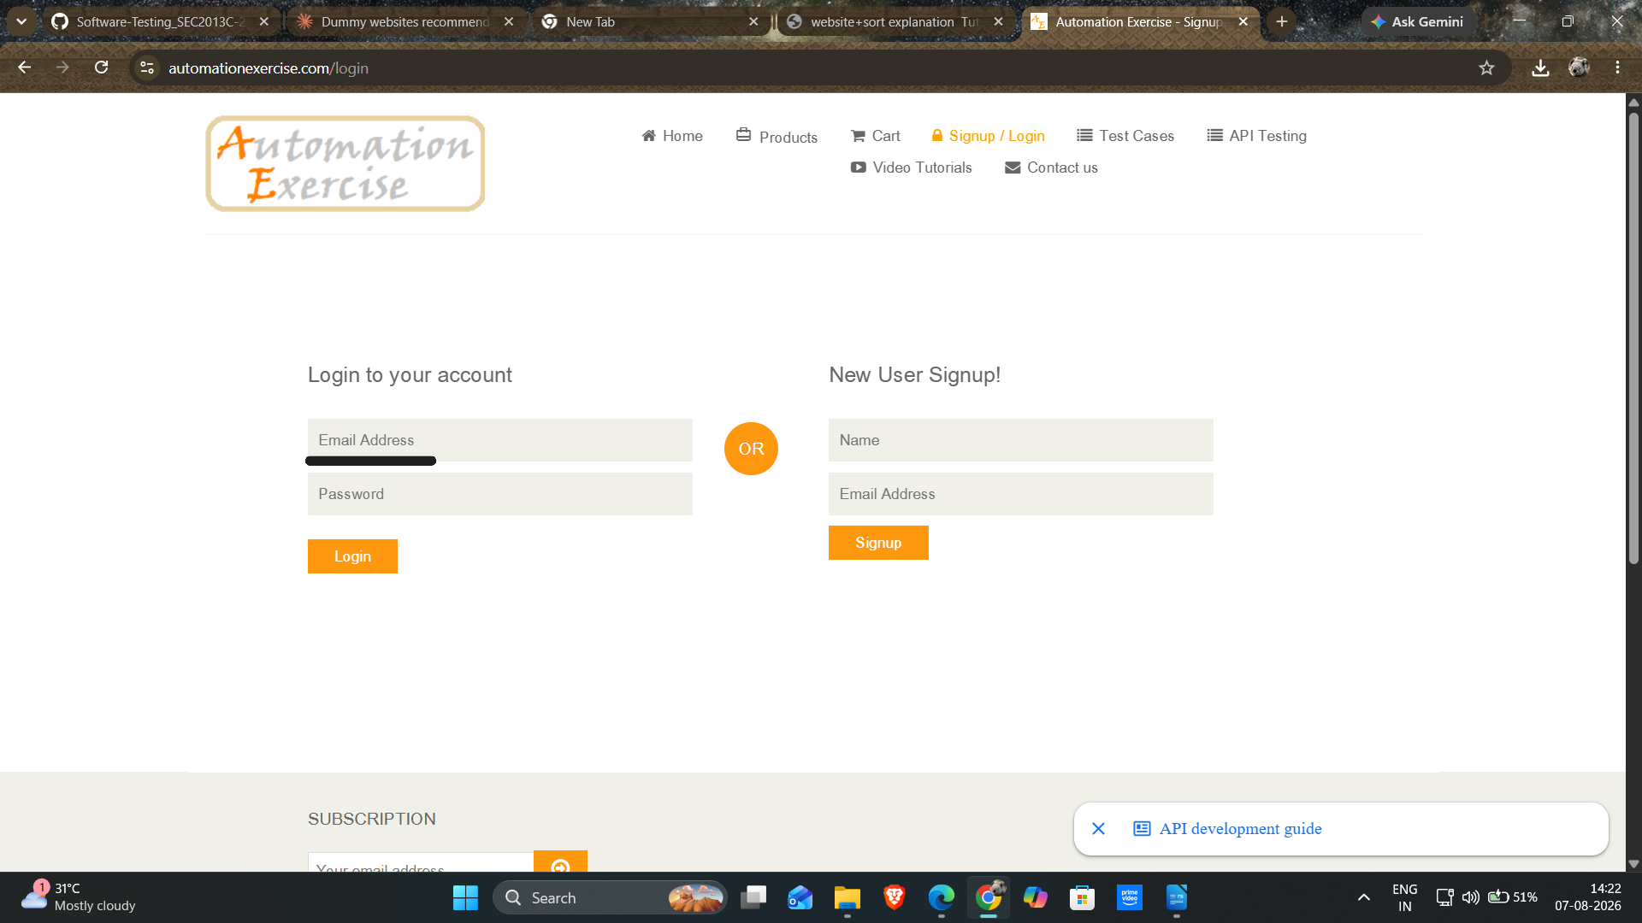
- Scenario ID : TC04
Scenario : verify password field is available on website .
Steps:
1. Navigate to Login page
2. Locate the 'Login' section
3. Check for the password input field .
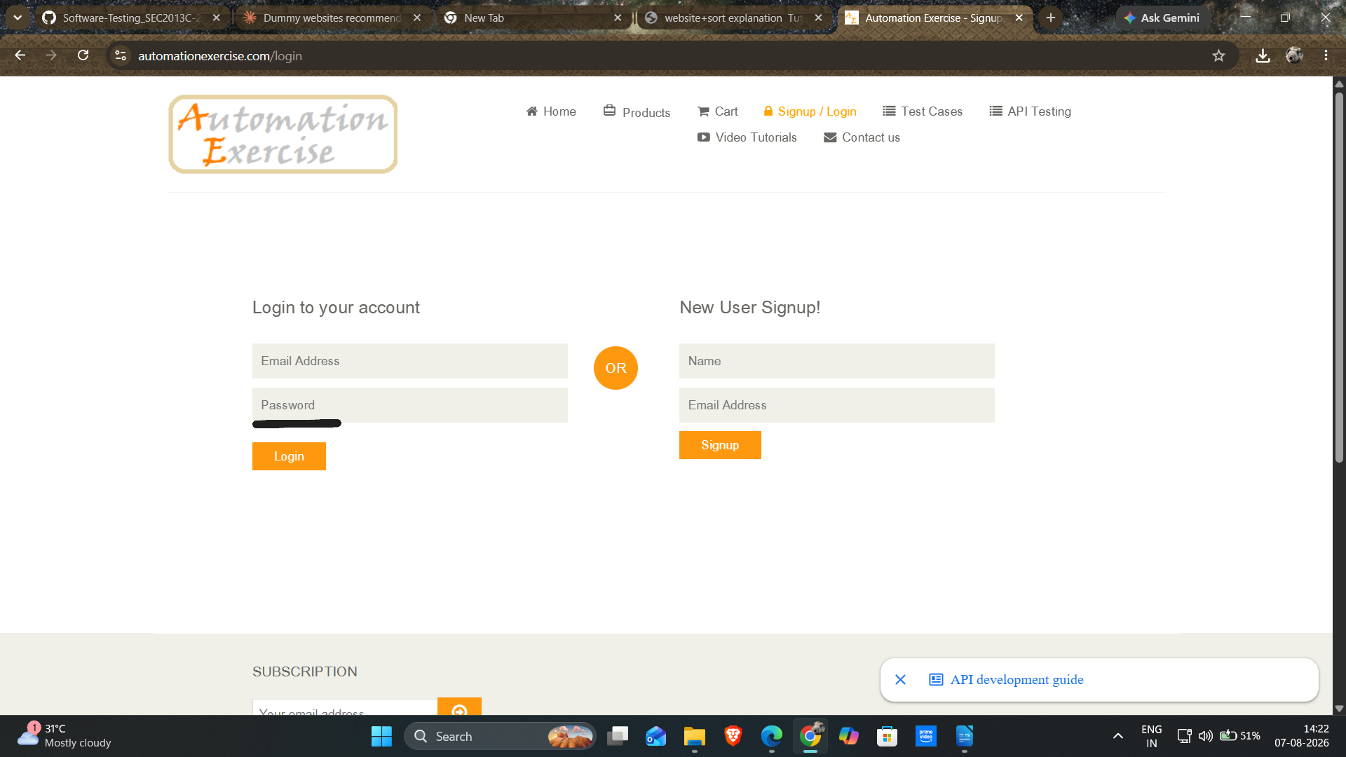

- Scenario ID : TC05
Scenario : sign up on a website .
Steps:
1. Click on sign up.
2. Enter name and email address.
3. Fill basic details
4. Click on create account
5. Account is created
Screenshots :
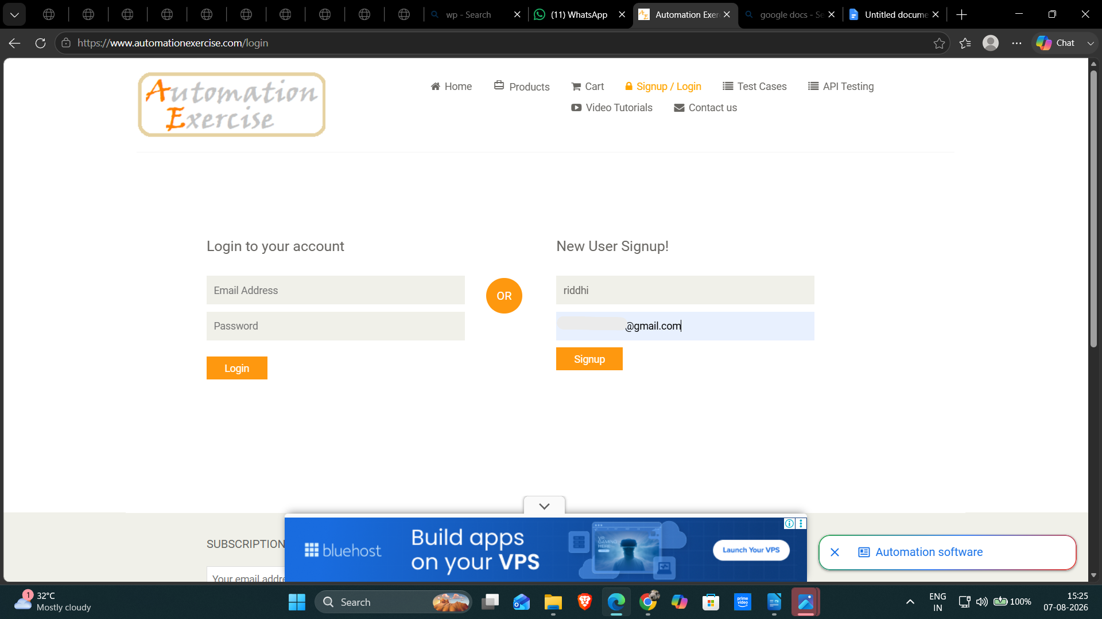

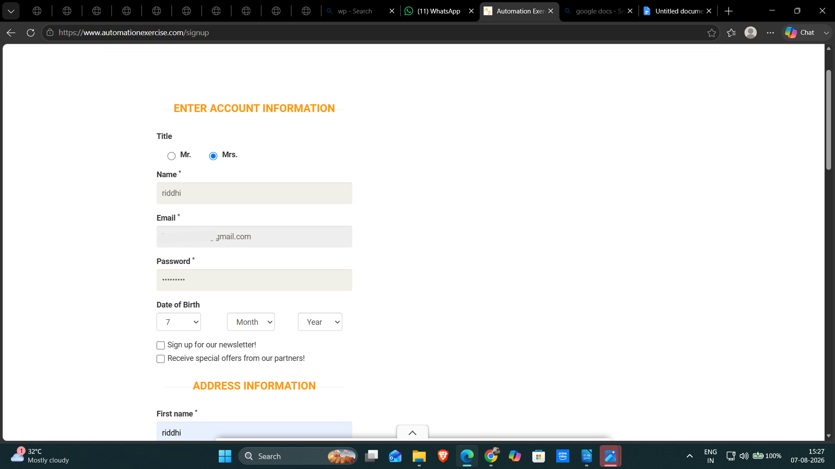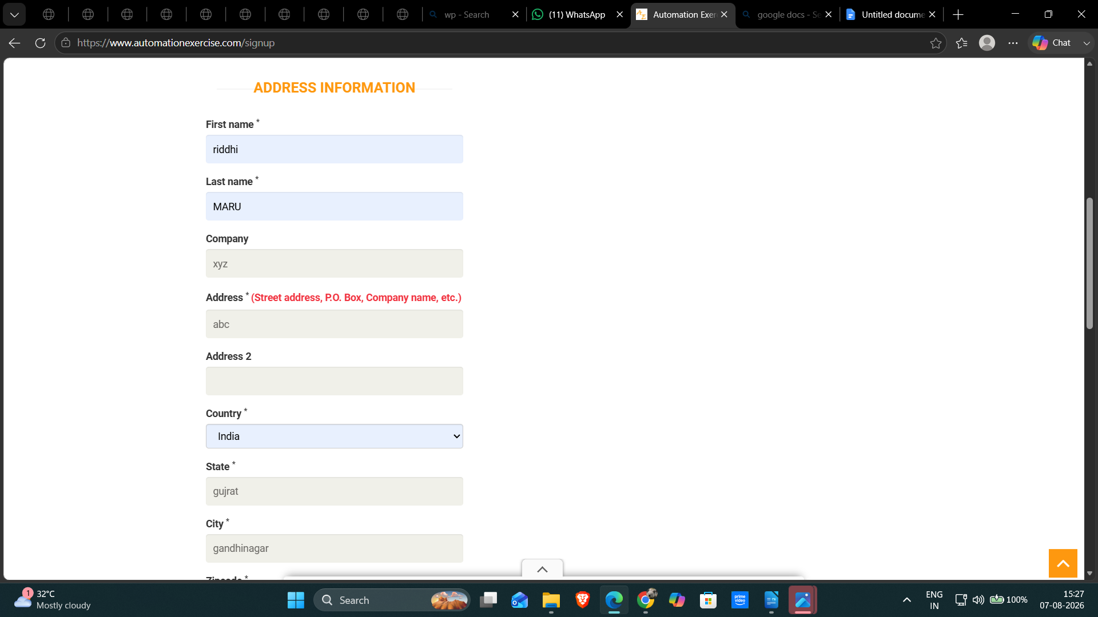

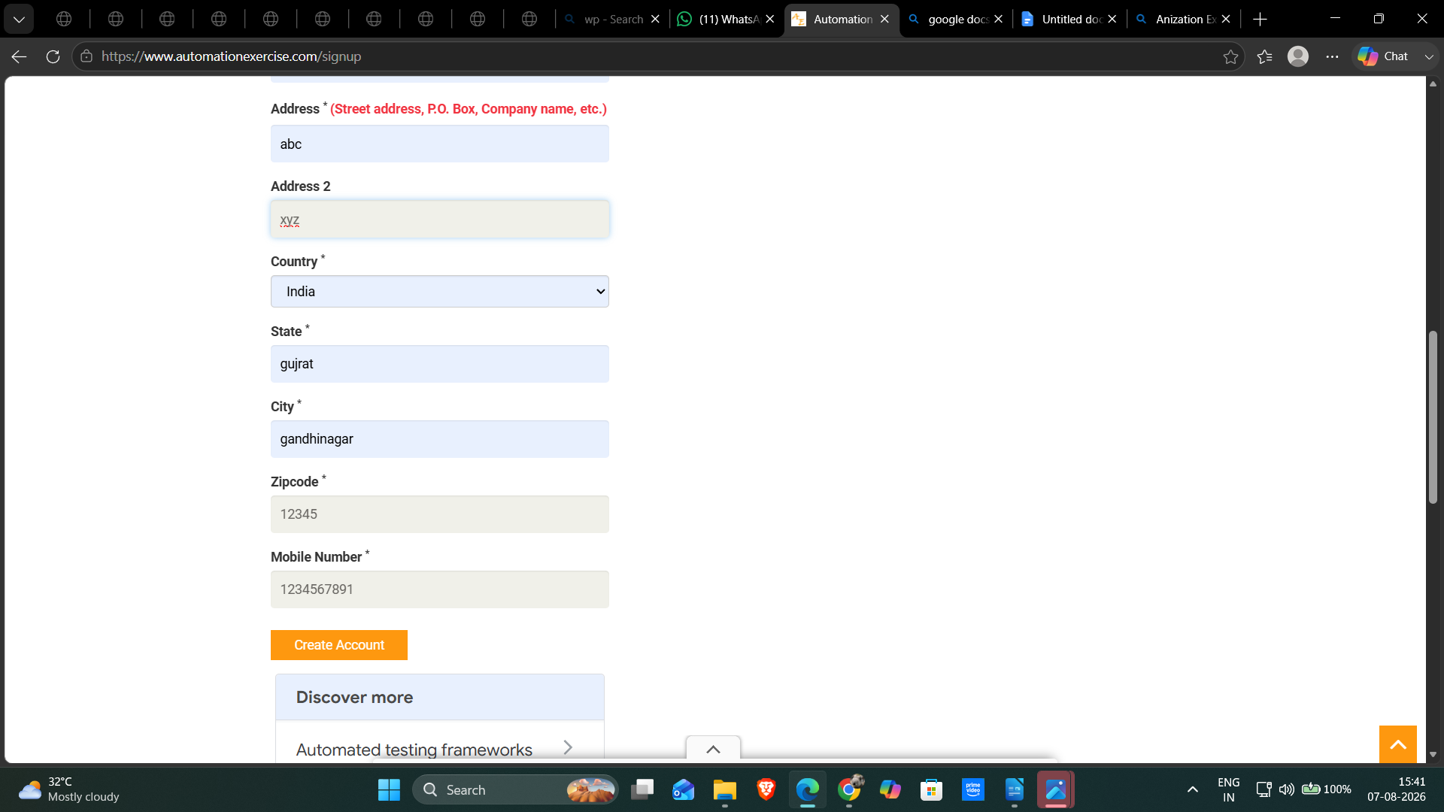
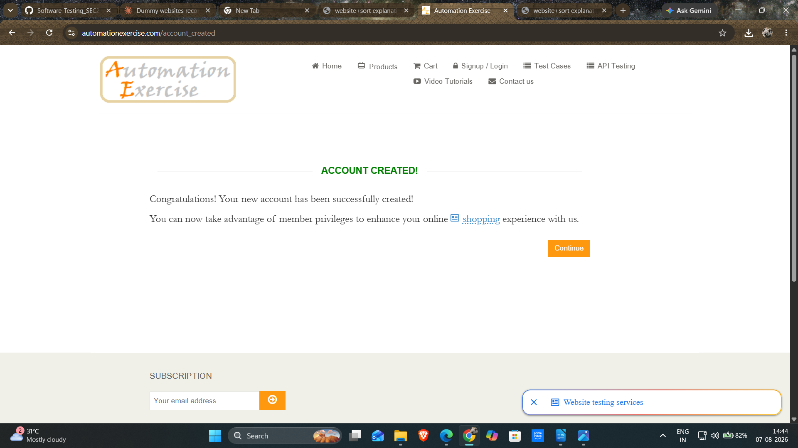
- Scenario ID : TC06
Scenario : sign up with already existing email .
Steps:
- click on sign up
- Enter username
- Enter already existed email id
- Click on sign up.
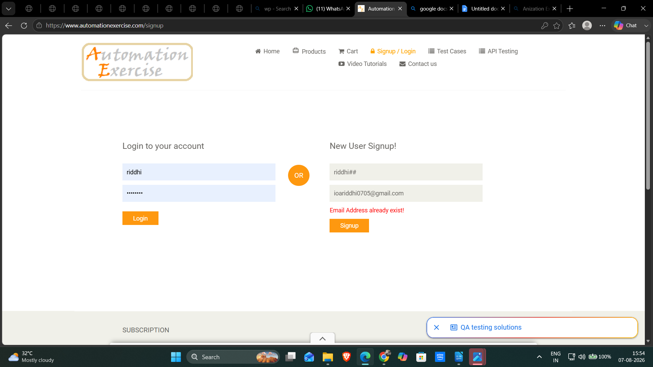
- Scenario ID : TC07
Scenario : delete the account .
Steps:
- Open a website
- Click on delete account
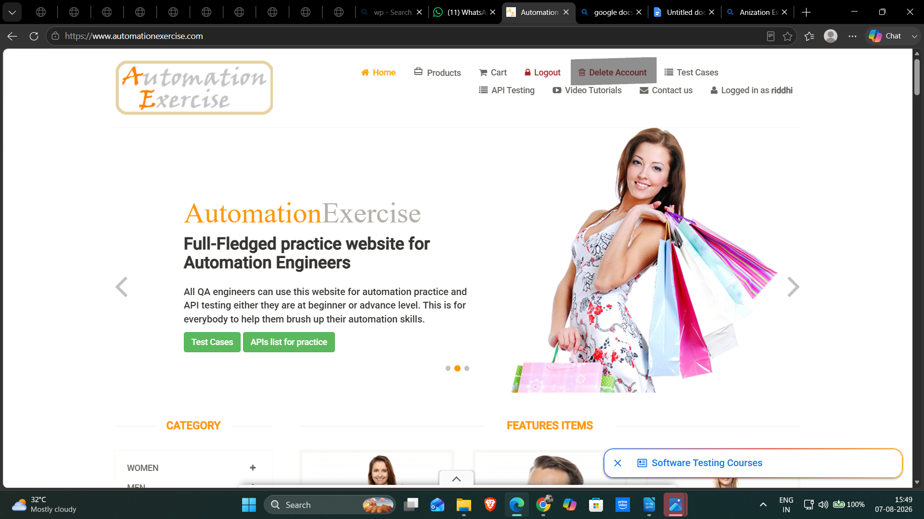

- Scenario ID : TC08
Scenario : log in with incorrect password .
Steps:
- Click on login.
- Enter the email id
- Enter an incorrect password

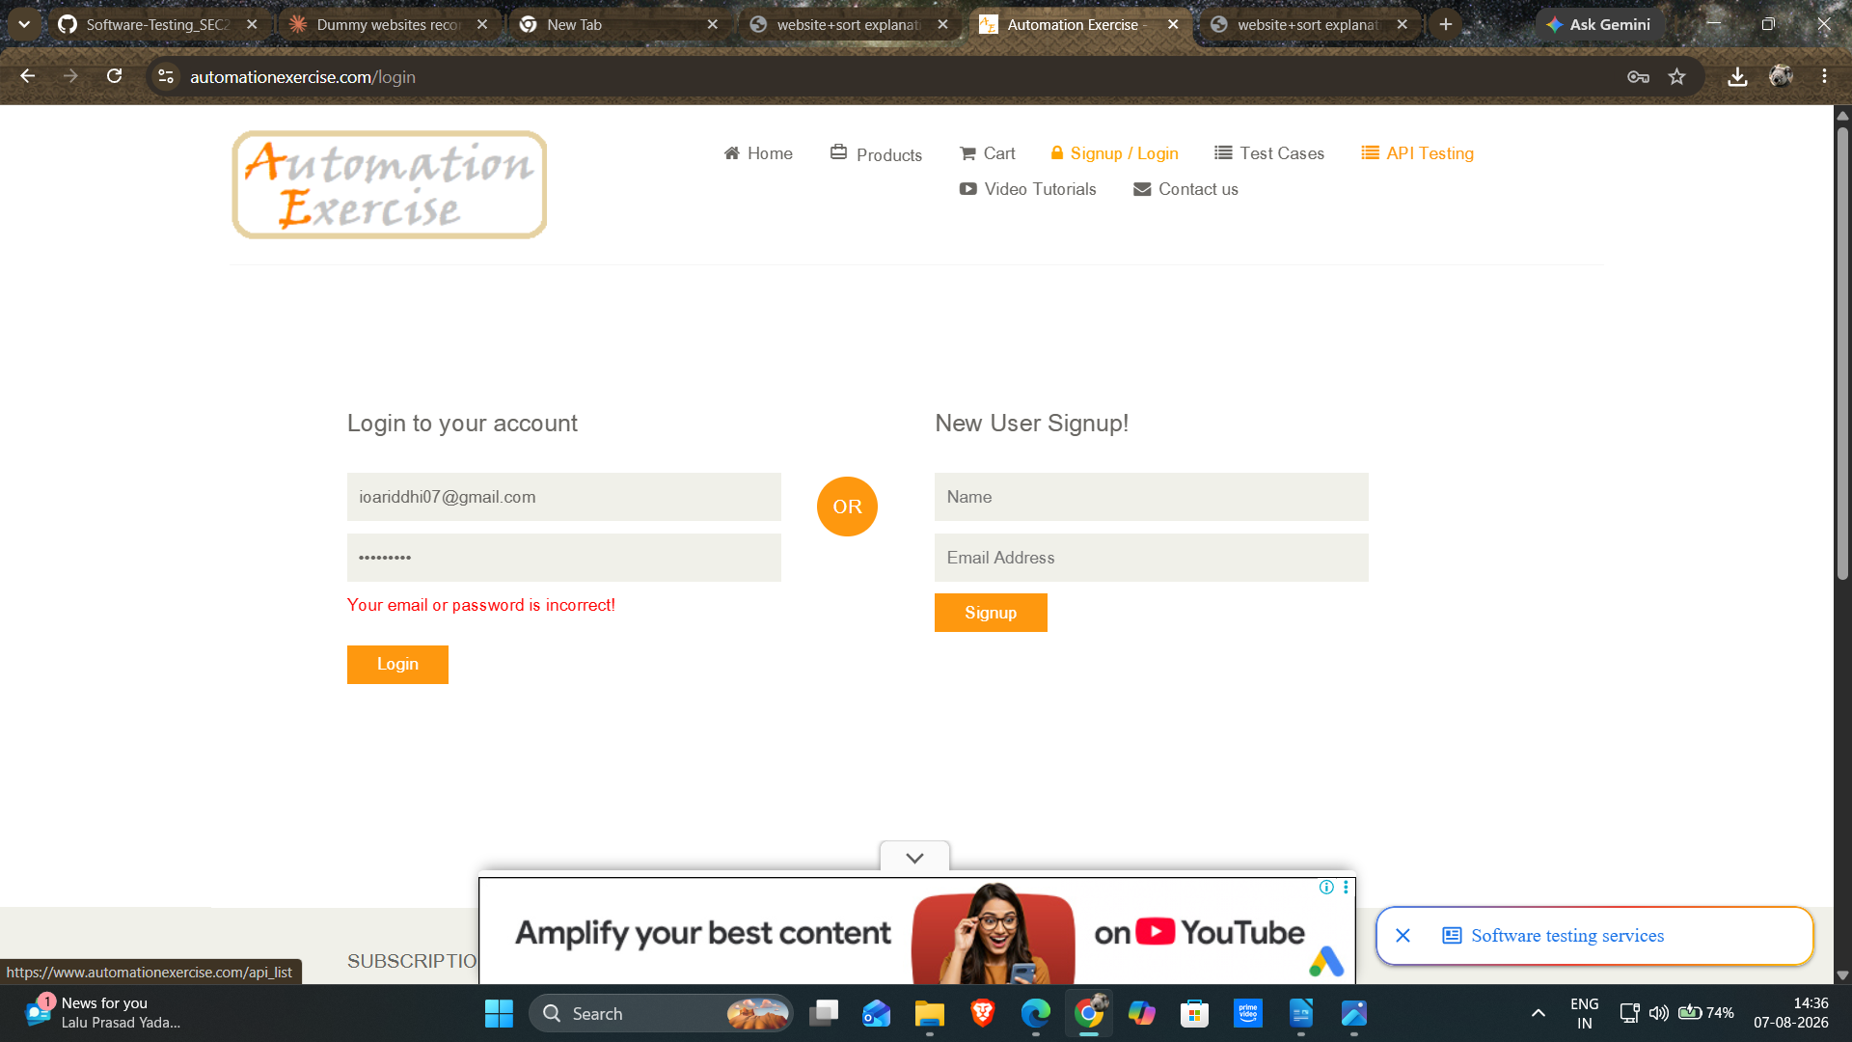

- Scenario ID : TC09
Scenario : login with empty fields.
Steps :
- Keep fields empty
- Click on login with empty fields
